Chapter 13, Problem 48.

Using Fig. 13.113, design a problem to help other students better understand how ideal transformers work.
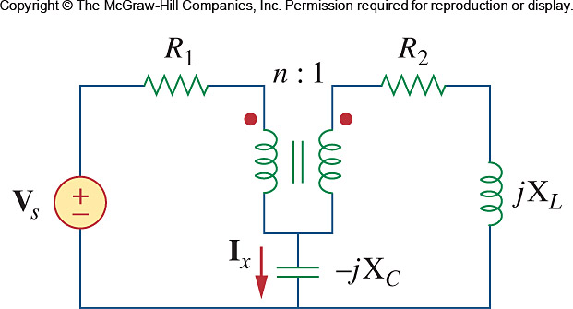

Figure 13.113
For Prob. 13.48.

